21. Perform Sharpening of Image using Laplacian mask implemented with an extension of

diagonal neighbors,

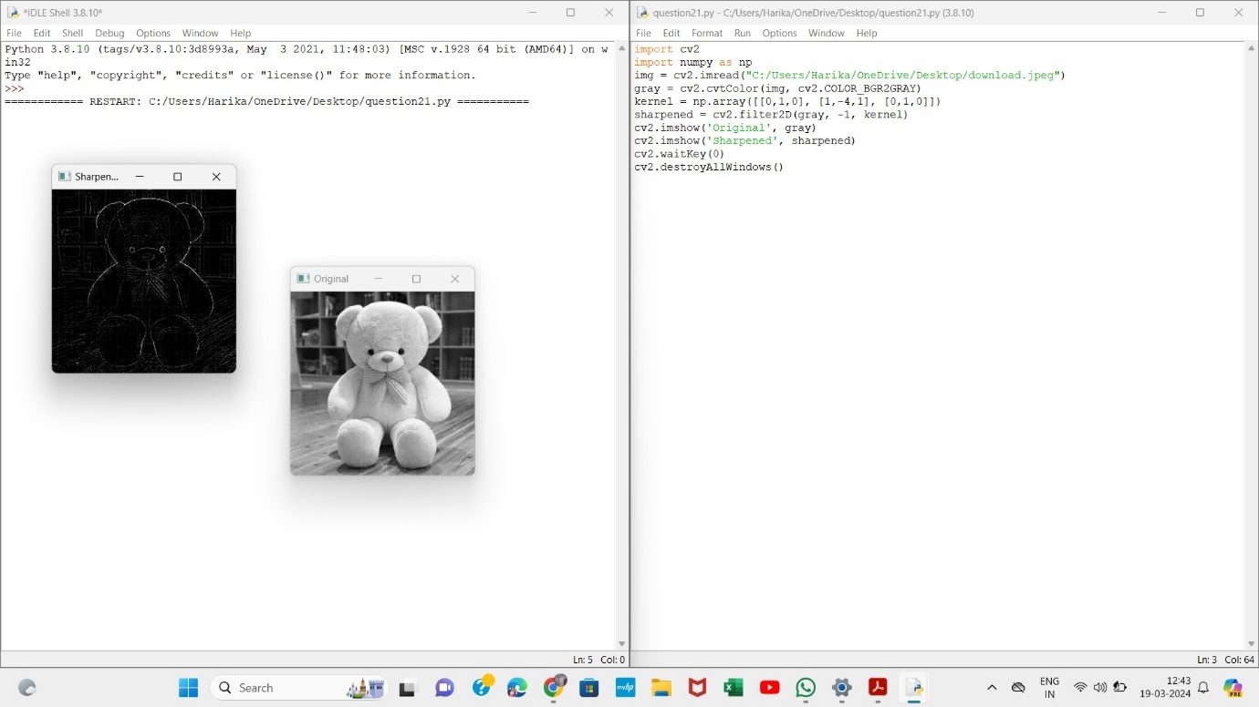

22. Perform Sharpening of Image using Laplacian mask with positive center coefficient.

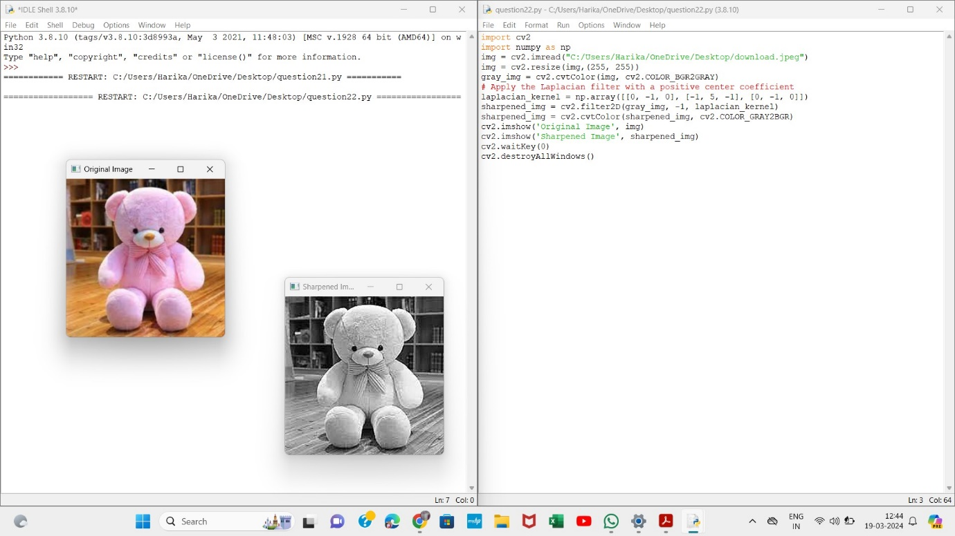

23. Perform Sharpening of Image using unsharp masking.

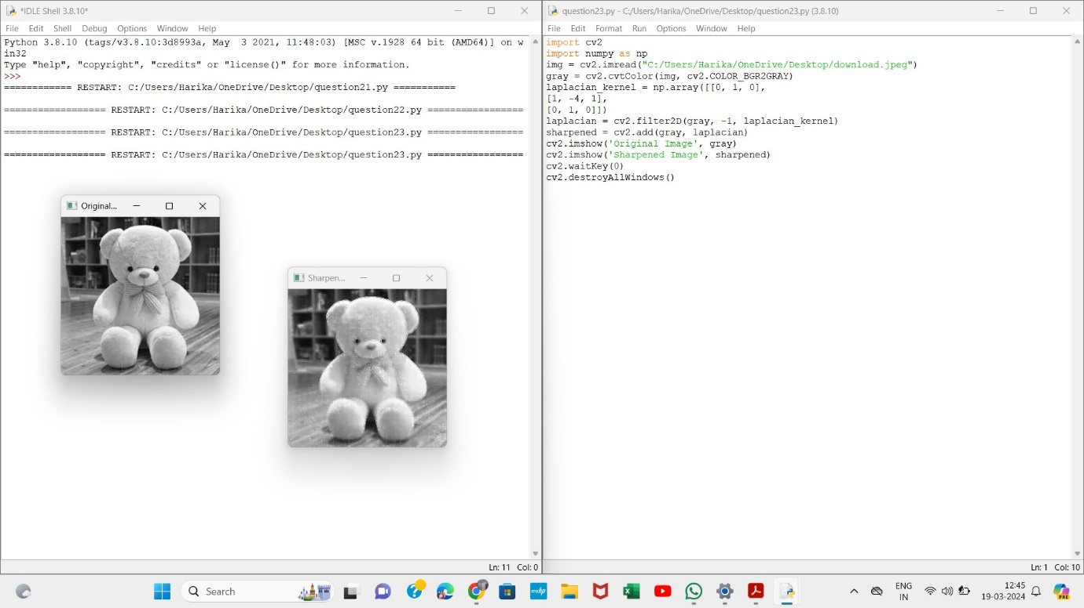

24. Perform Sharpening of Image using High-Boost Masks.

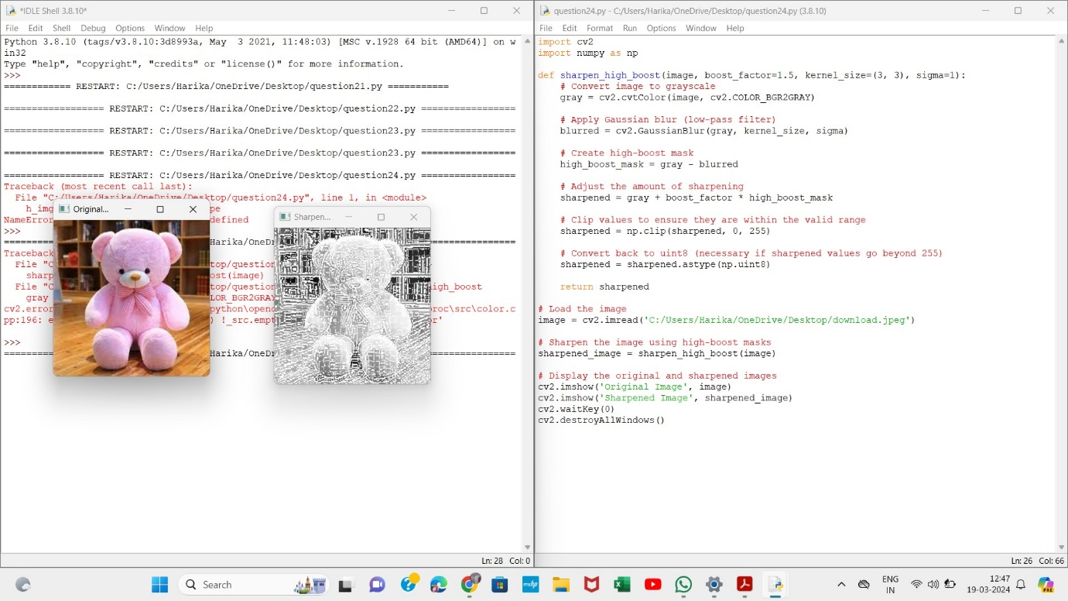

25. Perform Sharpening of Image using Gradient masking

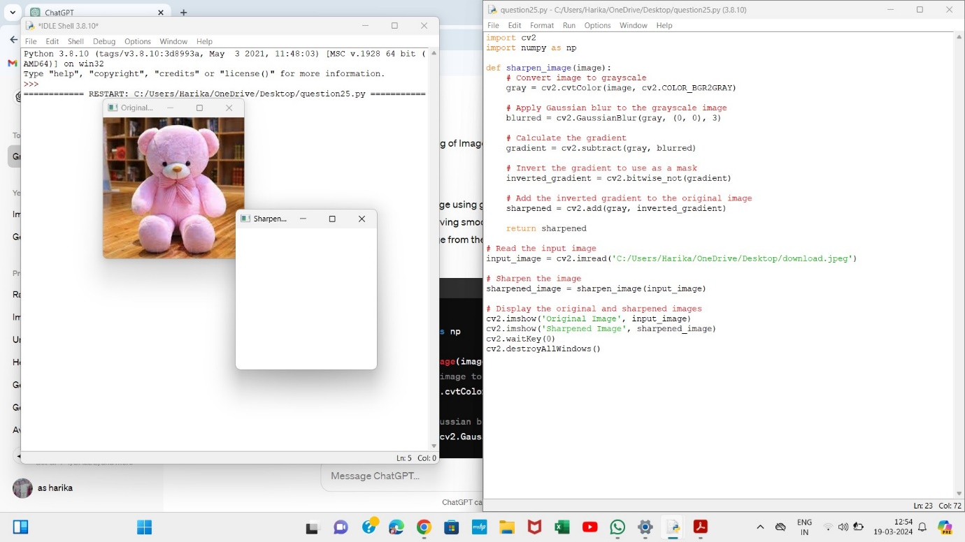

26. Insert water marking to the image using OpenCV.

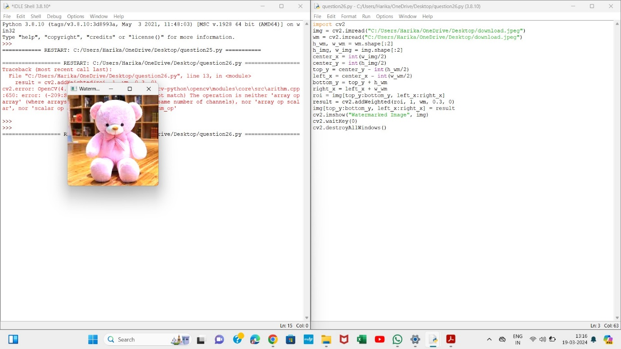

27. Do Cropping, Copying and pasting image inside another image using OpenCV

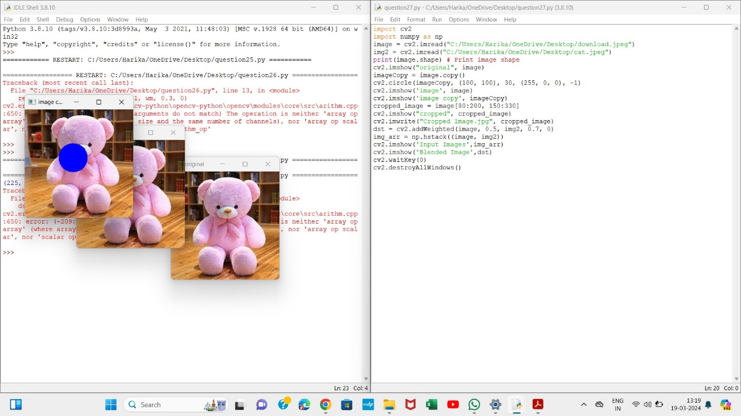

28. Find the boundary of the image using Convolution kernel for the given image

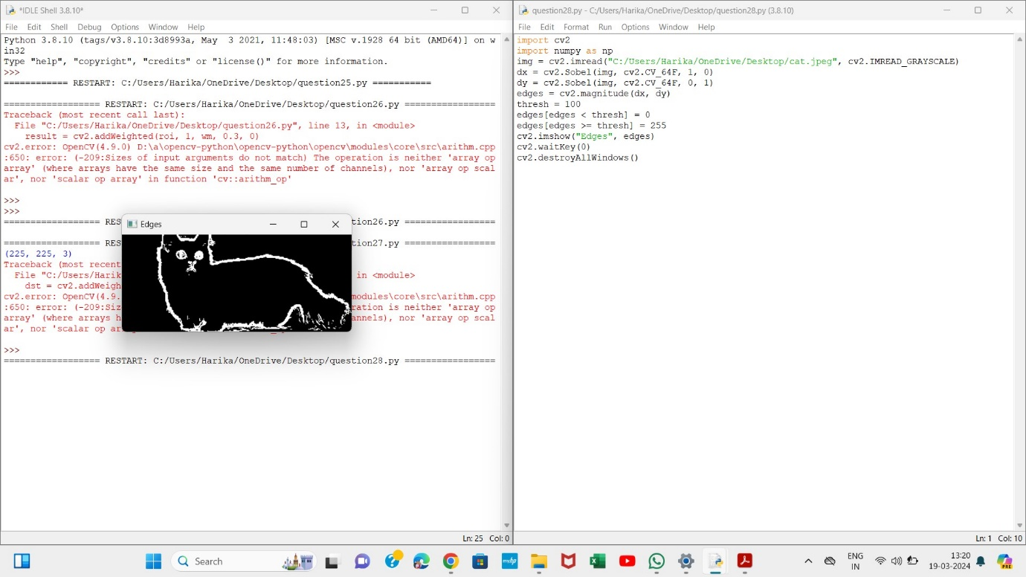

29. Morphological operations based on OpenCV using Erosion technique

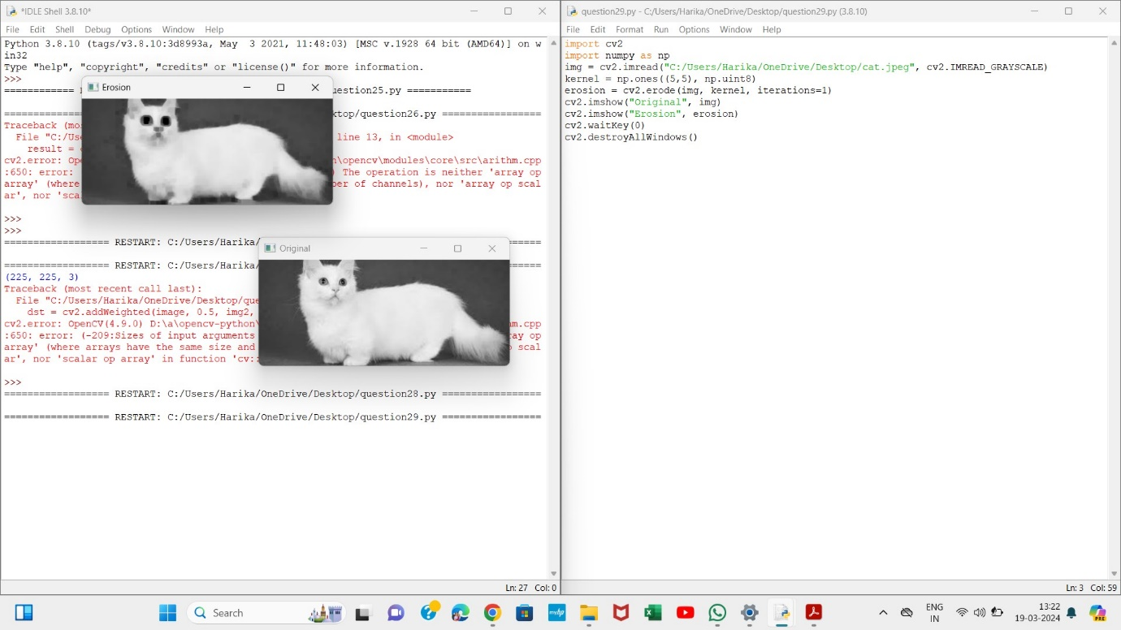

30. Morphological operations based on OpenCV using Dilation technique

